CHESAPEAKE BAY FLAG ASSOCIATION
Minutes—May 9, 2019—Zoom Conference Meeting
11:00 am to 2:30 pm

Present: Jack Lowe (Host), John Andrews*, Peter Ansoff, Nick Artimovich, Chris Bedwell, Al Cavalari, Stan Contrades, Ted Dahlburg*, Mike Del Duca*, Art Etchells, Dale Grimes, Chris Maddish, Melvin Mason*, Jon Radel, David Wagner, Connor Wright* (*-first-time attendee)

Jack welcomed all the new participants. He reported that the treasury held $250 after the purchase of the extended Zoom capability and, having no anticipated expenses, could do without auctions for a while.

Jack then introduced Nick Artimovich, a past president of NAVA and one of the founders of the CBFA. He gave a description of the CBFA flag and its symbols.

Peter Ansoff, the President of NAVA gave an update. The June 2020 annual meeting will now be held online on a platform of the Library of Congress (arranged by our member Betty Brown). The St. Augustine meeting has been postponed a year and will be NAVA-55. Peter invited any NAVA member to call into the Board meetings each month.

After a round of introductions, vexi-bits (show and tell) were interspersed with slide show presentations. Dave Wagner spoke on the history of the flags of Finland. John Andrews gave a talk on the Iraqi flag since Saddam Hussein’s modification of it in 1991. This talk was based on John’s M.A. thesis at the University of Maryland. Al Cavalari gave a talk on flags on postcards, showing examples from his immense collection. Peter helped explain Nelson’s signal flags at Trafalgar which appeared on one of Al’s postcards. He also told us about the Flat Earth Society. According to them, the UN flag shows that the earth is flat!

We had a mini tour of Nick’s amazing collection, including examples from his obsolete flags collection such as an old Trinidad and Tobago red ensign.. Some of Nick’s treasure can be seen on Flickr at nicka21045.
In the vexi-bits section, Chris M showed us a few items from his blog http://zebratigerfish.blogspot.com/ , including Japanese signal flags. During the meeting, he created a flag for this first video CBFA gathering.

In Chris’s words: “Attached is the virtual flag, made on the fly during the meeting. It makes so much sense, since this flag only exists virtually for a virtual meeting, in a virtual world. The ‘Japanese-like’ flag in between the stripes is not a Japanese flag, rather it is the International Maritime flag for the Number 1, slightly modified. The red dot should be off set towards the hoist, but due to overall harmony, it made more sense to center the red disc.

I suppose the second meeting would use ICS number 2 flag, which would be a white dot on navy blue?

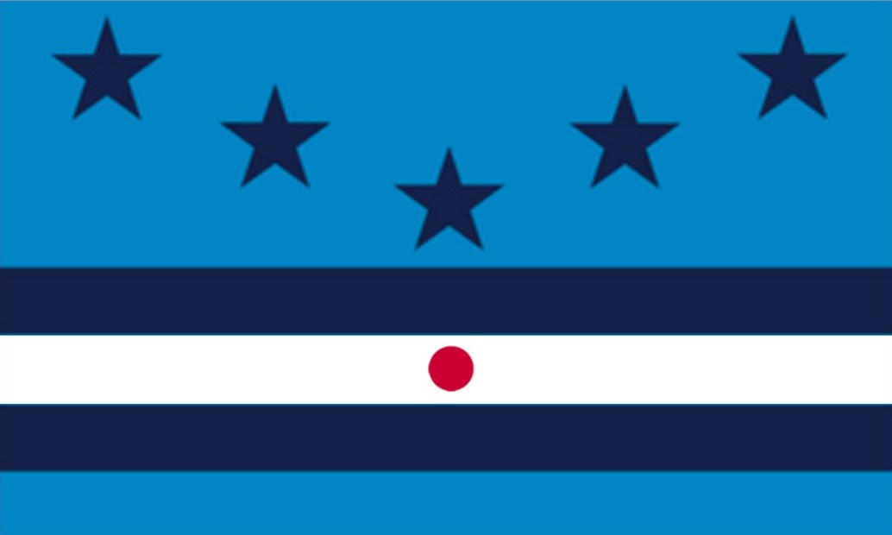

Art showed two Sienese palio flag scarves. Mike showed us several of his table flags and a number of flags on old cigar cards from 1910. Ted talked about sports flags and flags at sporting events. He also showed a Chinese (KMT) sun flag his father (going strong at 101) got in China during WWII.

Connor described the flag he designed for his home town of Catonsville, MD and there was discussion as to how he might promote it. Chris B showed an embroidered (double-sided) New York City flag and obsolete Iraqi flags, including the infamous crescent and blue stripe proposal of 2004. Dale showed us, among others, several WWII service flags, Coast Artillery flags, and an odd 48-star casket flag that was originally 49 stars, but one had been removed! Jack showed his DC flag T-shirt and reminded everyone about the website www.dcadapters.org/home. He also showed the flag of Saguenay. PQ, which has a gray cross (an unusual flag color), representing aluminum.

Melvin informed us that the guided tours of the historic Congressional Cemetery in DC are now virtual, every Saturday at 11 AM on Facebook Live and recorded ones are on the website. (Great for people who haven’t previously been able to get to DC.)

