CBFA Meeting at home of Peter Ansoff, Annandale, VA—March 17, 2018
Attendees: Peter Ansoff, Nick Artimovich, Chris Bedwell, Betty Brown, Tom Carrier, Stan Contrades, Dale Grimes, Mark Henderson, Dick Libby, Jack Lowe and Greg Nedved
His house adorned with Irish flags, inside and out, Peter welcomed 11 members gathered to talk about flags. Lunch contained green-iced cookies for the occasion.
Peter began by reporting on the NAVA-51 conference in Boston in October. He outlined the talks and commented on the business meeting and the overwhelming support to improve the NAVA experience for its members.
Jack Lowe discussed the future of CBFA. He has been serving as CBFA’s president since 2005. The group asked him to stay in that capacity and he agreed to. We discussed where future meetings should be and whether we could pull off a weekday meeting or an overnight excursion. Hopefully the next meeting will be around Flag day in June.
Tom Carrier began a discussion about the flags of Kekistan and the Anarcho-capitalists, which had been the subject of a recent news report in northern Virginia because of neighbors’ reaction to a man’s flying them in front of his house. Rather than condemning, as vexillologists we should study, understand and interpret how some flags can make people uncomfortable. What gives flags power?

Some highlights of the show and tell period:
Stan Contrades brought a small 50-star US flag which he had carried in his chest plate when deployed in Afghanistan. He also showed a banner from France designed for the 50th anniversary of the Normandy invasion in 1944.
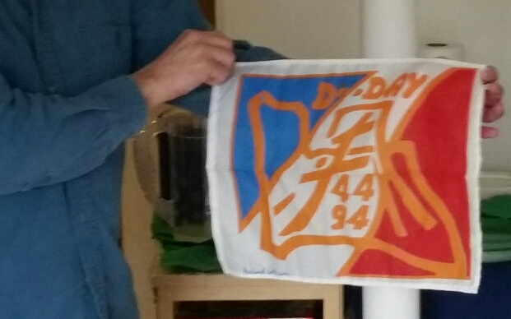

Nick Artimovich showed several flags including the flag of the Provisional Military Government of Socialist Ethiopia (1974 - 1987).
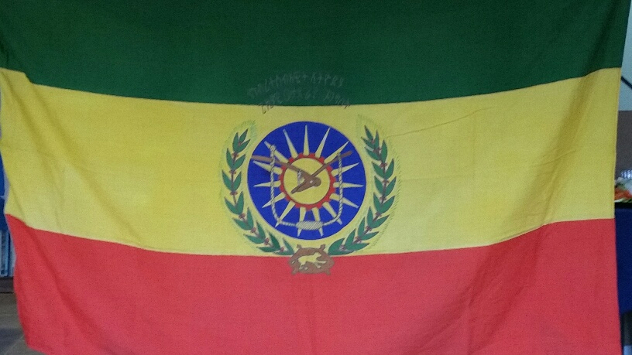

Dale Grimes showed a UK union flag which had been made at Mare Island. He also had a silk handkerchief with dozens of flags, which was from the SS Kronprinz Wilhelm passenger liner, interned in Norfolk in 1915, and seized when the USA entered WWI. The handkerchief is ca. 1901, and has stamped on it USS von Steuben, which was its name as a troop transport.

