CHESAPEAKE BAY FLAG ASSOCIATION
Minutes—May 11, 2019—Phoenix, Maryland
11:00 am to 4:00 pm

Present: Jack Lowe (President), Tom Carrier (Recording Secretary), Daniel Broh-Kahn (Host),
Nick Artimovich, Peter Ansoff, Dennis Flannery, Philip Flannery, Jon Radel, Joe Radel, Alex Radzius, Nora Radzius, Ethan Stearns, Matt Stearns, David Wagner.

Our thanks to the Broh-Kahns for a great catered lunch of roast beef, BBQ, potato salad, cole slaw, baked beans, cookies and brownies, not to mention the wonderful craft brew ale and lemonade. Quite the treat.

NAVA Update

Peter Ansoff, NAVA president, started discussions with vexillography, an issue on which NAVA is currently divided. The issue concerns the design of flags and centers on its publication ‘Good Flag, Bad Flag.’ The concern is that no flag should be called ‘bad’ simply because it lacks artistic merit. That connotes a distinctly negative reaction from the community that created the flag. Instead, a more diplomatic approach that suggests a better design might work better, potentially with NAVA’s help. Others disagree saying that a poorly designed flag should be recognized as a ‘bad’ flag. Some say that advocacy ought not be a NAVA function.

Therefore, NAVA’s Facebook presence now includes three separate pages: Flags and Vexillology, Designing Flags, and NAVA Matters (for topics about the organization, not directly about flags)

Peter also announced that Vexillum 6 is at the printers, with an issue of Raven being issued shortly as well.

CBFA Update

Jack Lowe mentioned the lack of progress on CBFA’s website. Jon Radel introduced his son Joe, a senior at Robert E. Lee High School. Joe proposed helping CBFA with its online presence to earn his school program credit for helping a nonprofit. Joe will gladly accept suggestions at joe@radel.com.

Jack mentioned that members who have collections of research books, materials and ephemera on flags should consider, as part of their estate planning, contacting the Whitney Smith Flag Research Center collection, in the Briscoe Center for American History at the University of Texas in Austin, to see if they ae interested in donations.

Jack asked for suggestions for meetings at vexillology-related venue. In the past, CBFA has visited the Smithsonian, the Naval Academy, the White House, Winterthur, Flag House in Baltimore, etc.

We thanked Jack for his participation in an NPR program about the flags of DC, Virginia and Maryland. You can hear the broadcast here. He even wore his Maryland flag socks to the meeting.

Meetings Update

The ICV 28/NAVA 53 is coming up on July 15-19 in San Antonio, TX. Jack will be the official delegate to the FIAV General Assembly unless others are interested in that role. ICV 29 will be in Ljubljana, Slovenia in July 2021.
Peter reminded NAVA members to vote online (June 11-July 2) for officers. NAVA 54 will be in St. Augustine, FL in JUNE (not October) 2020.

Member Presentations

Tom Carrier provided verbal Vexi-Bits about flag stories making the news:
- New Jersey removes the Mississippi state flag from the Statue of Liberty State Park for including the Confederate Battle Flag in its design.
- An African-American employee settled a lawsuit in the Oregon County Department of Community Justice for the display of a Blue Lives Matter flag in the office.
- The police department of Laguna Beach CA issued a new US flag inspired design for its police cars some residents suggested was an attempt at intimidation and harassment.
- An art exhibit at the Fabric Workshop and Museum in Philadelphia features a white dish towel that was used as a ‘surrender flag’ during the Civil War
- A vertical tri-color flag of red, green, and navy blue is considered to be the Flag of Mars, the planet.
- CNN had a story on the ‘Blutfahne’, a Nazi ‘blood flag’ used in ceremonies that went missing and presumed lost during the war.
- Possible Kashmir-related attempt to discredit Pakistan led to the flag of Pakistan showing up after a search for the world’s best toilet paper.
- A FedEx driver was lauded after he stopped his truck, picked up an American flag from the ground of a front lawn, carefully folded it and placing it in a box on the porch.
- The Oval Office now sports three sets of the US and presidential flags instead of the usual one set behind the Resolute Desk. The service flags of the military branches and their battle streams are also prominently displayed for the first time in the Oval Office.

Jack recommended that people subscribe to the Vexi360News email (vexi360news@gmail.com) for all the latest flag stories in the press and online.

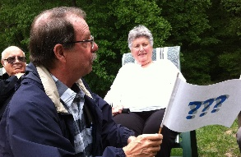
Peter Ansoff presented his Speculation Flag, three blue question marks on a white field, as a teaching device in his ‘History of the American Flag’ lectures to show what the best guesses for the origins of the American flag design (all speculation). The use of stars and the inspiration of the stripes may not be as straightforward as we have been taught all these years.

David provided a unique study of the use of lions and eagles in the flags of Europe with a translation in Finnish. He also showed a picture of a truck painted with the flag of South Africa with the fly end tapering into multi-colored streamers—reminiscent of the Flag of Unity in Diversity described in Vexillum 2.

Nick Artimovich provided visuals of a recent acquisition of flag remnants, parts of flags that were not used; a Canadian Badge from 1920 to 1957 and an Arab Federation eagle. A most unusual flag for the Canadian Ammunition Park 1st Contingent from WWI, a Royal Standard c. 1900 showing the bare breasted harp for Ireland (later covered), a WWII Coast Guard flag showing the stars in a rainbow pattern rather than a circle of stars, and a 1918 ‘Germany Surrenders’ parade flag waved at the actual announcement as written by its previous owner. Other US flag-related ribbons were passed around.

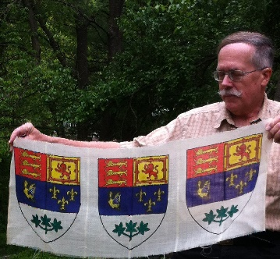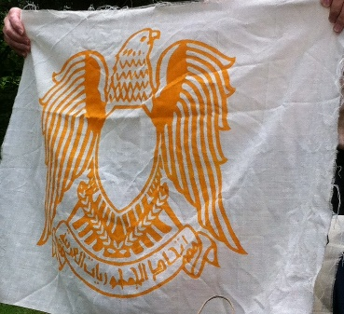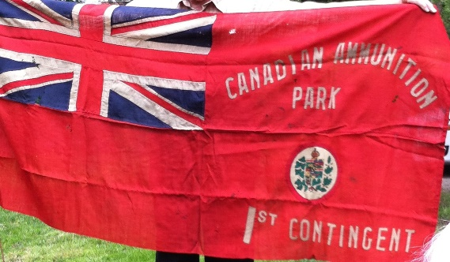

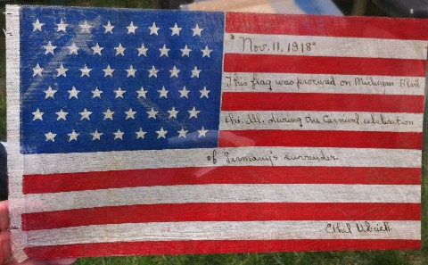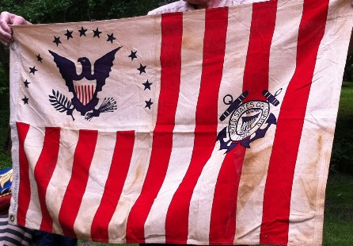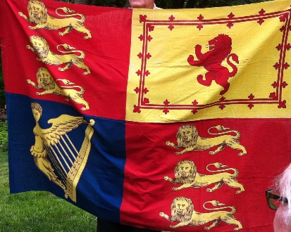

Ethan told the story of rescuing an American flag that was caught on an eagle finial at the top of his middle school flagpole where he helps raise the flag each morning. He also mentioned that he has designed new flags for three NHL hockey teams: the Caps, the Bruins and the Penguins. He’ll bring them to the next meeting.

Jon Radel told the story of a well-meaning school that wanted to show each student’s heritage by displaying the flag of their country of origin. One student was from Georgia and so the teacher added the flag of the state of Georgia, instead of the Republic of Georgia.

Other similar stories emerged about the use of the current Vietnamese flag, which often upsets the Vietnamese-American community, most of whom fled from the regime that adopted the gold-star-on-red flag. They prefer to use the three red stripes on yellow of former South Vietnam. Similarly, conflicts arise with use of the People’s Republic of China flag versus the flag of the Republic of China (Taiwan/Kuomintang). He also told a story that the St. George cross flag of Genoa was borrowed for the St. George cross of England. There was supposed to be an annual payment to Genoa that has been arrears for the past 200+ years.
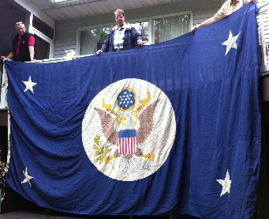
Tom Carrier showed off his overlarge official flag of the Secretary of State to those who hadn’t seen it at the last meeting. The size is 10’ x 16’ feet and is perfect for backdrops and photo ops at rallies. If it sells—the asking price is $500—10% will go to the CBFA fund. (Tom is at thompersonal@gmail.com)

Later we went inside to view the enormity of Daniel’s large collection of heraldic and flag ephemera, particularly the striking display in the living room.

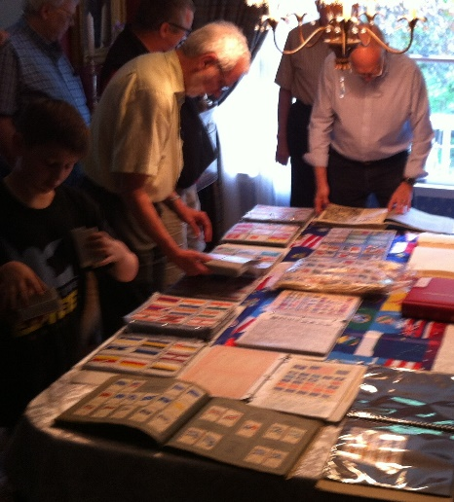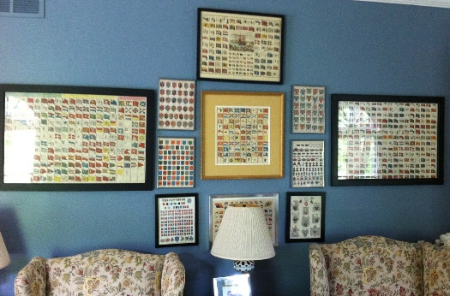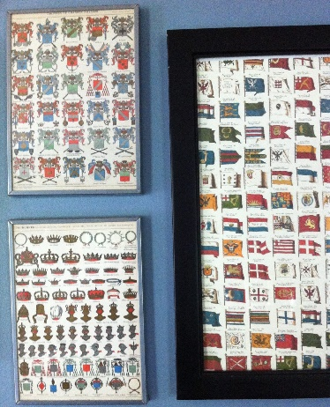

Our thanks to the Broh-Kahns for such great hospitality and to Tom Carrier for compiling the minutes.

