CHESAPEAKE BAY FLAG ASSOCIATION
Minutes — May 22, 2021 — Zoom Online
10:00 am to 3:00 pm (EDT)

Meeting to Order

President Jack Lowe brought the meeting to order at 10:00 am (EDT) and welcomed the newcomers. The meeting began with introductions. (First time attendees in Bold )

- Al Cavalari NY, owner, Flag Guys, NAVA member since 1989
- Art Etchells PA, military and historical flags, NAVA member since 1973
- Carlos Morales PA, subnational flags, research, NAVA member since 2015
- Chris Bedwell DC, subnational, city, obsolete flags, NAVA member since 2005
- Chris Maddish PA, history and flag patterns, NAVA member since 2008
- Daniel Broh-Kahn MD, UN flags, NAVA member since 90s
- David Wagner DC, national and historical flags, recent NAVA member
- Dejan Mraović TX, asst professor of graphic design
- Desmond O’Neill NJ, military flags
- Gus Tracchia NY, Latin American flags, NAVA member since 1981
- Jack Lowe MD, president CBFA, flag literature
- Jennifer Jones VA, curator, Smithsonian Museum of American, NAVA member since 2011
- John Baky PA, military, heraldry, researcher LaSalle University
- John Emond MD, American Rev/CW, NAVA member since 2011
- Jon Radel VA, cofounder CBFA, UN flags, Natl Geographic
- Nick Artimovich MD, cofounder CBFA, early American flags, collector, books, NAVA member since 1974, former NAVA president
- Peter Ansoff VA, President NAVA, Revolutionary War, general flags, origin of US flag, NAVA member since 1982
- Stan Contrades VA, VP of NAVA, collector, military, historian, NAVA member since 2007
- Tom Carrier VA, cofounder CBFA, official flags, president, government, NAVA member since 1980
- Tom Fahres MD, military, books, recent NAVA member

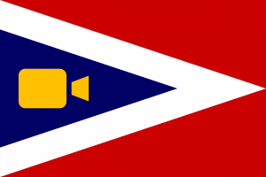

NAVA Update by President Peter Ansoff

NAVA Meetings Update:
- NAVA 55 will be a virtual meeting on June 12 via Zoom. Special presentations include a virtual tour of the US Coast Guard Executive Center, a panel discussion on the process of changing the MS state flag, and the keynote by the CEO of C3, the company responsible for the flags on the National Mall for the 2021 presidential inauguration.
- NAVA 56 will be an in-person meeting in St. Augustine, FL in 2022 with meeting dates to be announced.
- NAVA 57 will be held in Monterrey, Mexico, in 2023 the first time a meeting will be held south of the border. Meeting dates will be announced.

Vexillum 13 will feature flags from the January 6th, 2021, demonstrations in and around the US Capitol in Washington, DC. Al asked how articles were submitted and approved and Peter said that they are vetted and approved by NAVA’s Editorial Committee.

The NAVA Website is undergoing an overhaul by a new website provider to provide a better member database, calendars for local meetings, and other needed changes. Peter expects the new website will be online by the end of this summer.

Interest Area Meetings have been a great success. A wide range of topics that have generated interest in paper and materials such as flag design, historical flags, and others. Vexi-News will continue to cover the meetings and dates with everyone welcome to participate. Al asked if non-members can attend since it would be great for recruitment and the answer is yes.

NAVA Board Meetings are open to any member. Email Secretary Ted Kaye at sec@nava.org to get on the list.

FIAV will have its postponed 2021congress in July 2022 in Ljubljana, Slovenia.

Art Etchells announced the ‘Flags and Founding Documents: 1776 to Today’ featuring the flags of Jeff Bridgman at the Museum of the American Revolution from June 12 to September 6, 2021. Visit amrevmuseum.org for more details.

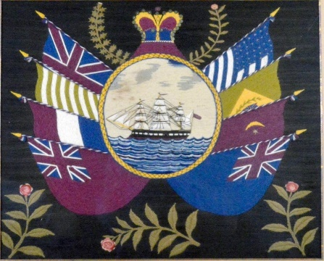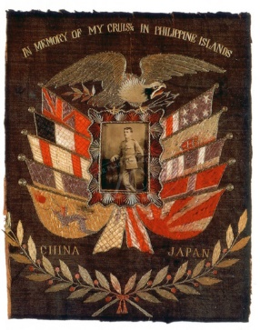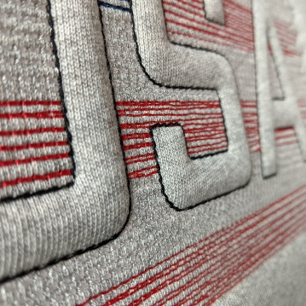
Examples of embroidery and trapunto

Nick Artimovich presented ‘Flags and the Sea - Souvenirs for Sailors and Seafarers’ that featured ‘woolies’, handcrafted flags of the Allies during WWI in wool, silk embroidered on tickets, badges and trapunto quilting that sailors took home to family and friends that sometimes featured a space for an image. Tom Carrier had some experience with the embroidered ‘sweetheart pillows’ that featured a pocket for a letter with also this type of embroidery and asked if they are similar to the framed ones and whether sailors still have these types of souvenirs to show off their deployments. Nick wasn’t sure on both.

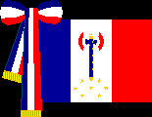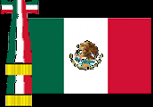

Gus Tracchia and Stan Contrades spoke about the types of ribbons known as cravats attached to the hoist or pole and used mainly for official functions. Some cravats are heavily embroidered with bullion or festooned with campaign medals. It is mostly a military custom--originally from Spain and France.

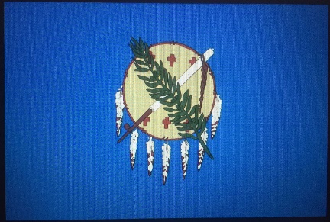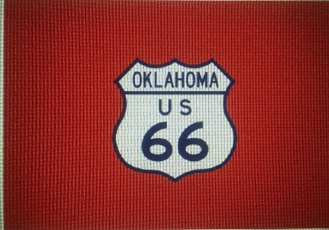
Dejan Mraović suggested a change of design for the flag of Oklahoma from the Native American symbol to a design that features the shield of Route 66, the old National Highway, which crosses the breadth of Oklahoma. Tom Fahres asked why there are six stars/crosses but seven feathers on the current flag. Dejan will research the answer.

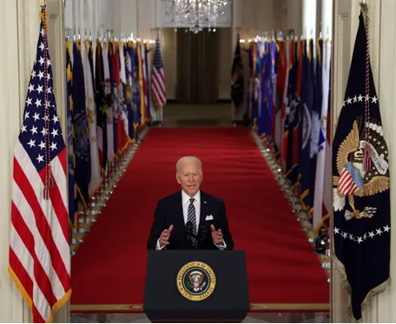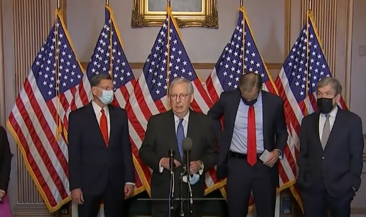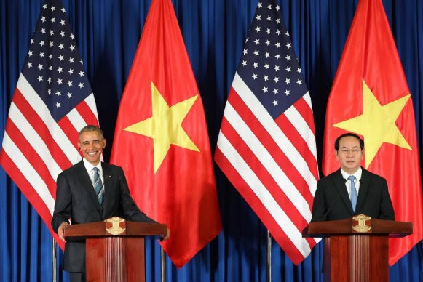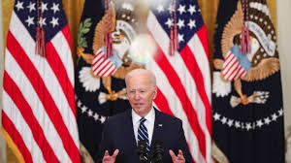

Al Cavalari was fascinated by the increased use of flags for presidential press conferences, particularly a recent one by President Biden at the East Room. Behind the President, along the Cross Hall, were the flags of all the states and territories. This hadn’t been seen before. We discussed the use of the US flag at White House events. Tom Carrier said that the US flag placed side by side, or multiple US flags interchanged with state or foreign country flags violated the Flag Code. It was suggested that these displays have become more of a decorative device and less a focus on national identity. The Trump Oval Office featured four sets of US and presidential flags, along with all the service flags; previous administrations only had the one set behind the desk and only occasionally the full set of service flags (usually in the Cabinet Room).

Al also mentioned that there is a shortage of flags for sale due to increased demand.

Jack Lowe updated the members on the CBFA website. Jon Radel’s son, Joe, had helped to improve it. The site is functioning but still needs additional content and continued update and asked for volunteers. Jon Radel offers his technical assistance, Carlos Morales would screen content, Jack would copy edit and Chris Bedwell and Jennifer Jones would work with content. Peter was asked if additional content would conflict with NAVA and other publications, and he thought not.

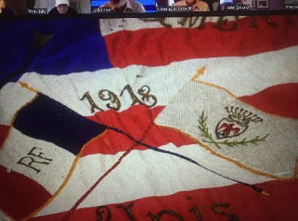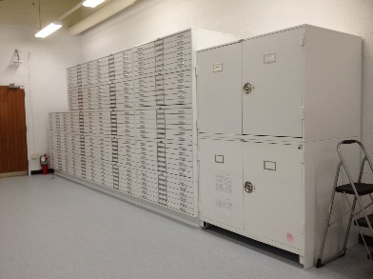
Nick Artimovich and Jennifer Jones talked about the flag collection of the Smithsonian Museum of American History, their restoration progress, and the new storage system for its Revolutionary and Civil War era flags. Jennifer says it takes 250 hours to fully conserve each flag. Flags over 10’ are difficult to photograph and store so there is a deaccession schedule being prepared for the largest flags. Jennifer will notify CBFA once the schedule is approved. We will also plan a CBFA tour of the new facilities once the Covid restrictions are lifted.

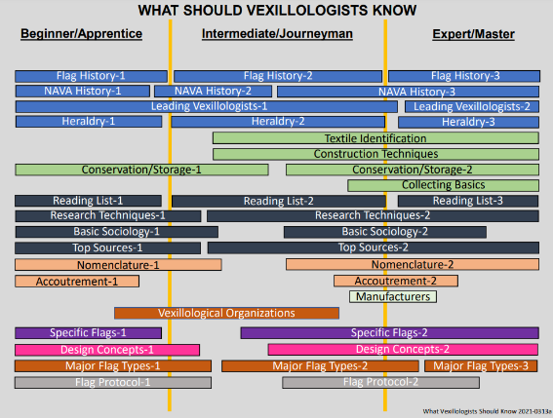

Stan Contrades showed a PowerPoint titled “What Should Vexillologists Know?” He catalogued the kinds of information a vexillologist could amass over a period of time, from beginners to masters. Tom Carrier thought that the word ‘should’ might put off some who are interested in flags by its professional sounding expectations. Discussion suggested that while comprehensive, the chart could seem intimidating to new--and even older--vexillologists and might best be used for instructor videos, short courses, Interest Area Meetings, and individual study.

Jack Lowe ended the official meeting at 2 pm. Tom Carrier continued the meeting with several attendees still online.

Vexi-Bits

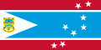

Chris Bedwell has a 1995-1997 flag of Tuvalu for sale.

Peter Ansoff is to be featured in a Washington Post article regarding Flag Day on June 9th in the Kids Post edition.

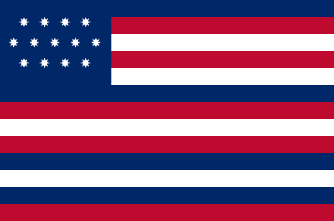

Al Cavalari asked Peter for a clarification about the flag aboard the Serapis, the British ship captured by John Paul Jones, and Nick asked whether the flag with the blue stripes was created in Europe. It wasn’t clear where it was made, according to Peter.

Jon Radel brought up the previous discussion regarding the use of the US flag in rows instead of individually to press the point that the Flag Code doesn’t necessarily disallow the practice. There was a spirited discussion about whether this usage indeed violates the Flag Code. The consensus was that unless the US flag is treated with disrespect, the Flag Code will grow and expand to allow for more current usage, especially as it translates into more video and social media applications. Unless there is a willingness to control the use of the US flag (no one here advocates that), the idea should be that flag usage is OK if there is proper intent and respect.

Meeting formally ended at 3:00 pm EDT.

Respectfully submitted,

Tom Carrier
Recording Secretary

