CHESAPEAKE BAY FLAG ASSOCIATION
January 24, 2021 — Zoom Online

Meeting to Order

President Jack Lowe brought the meeting to order at 11:00 am (EST) and welcomed the newcomers.

- Introductions * Indicates First-timer

- John Andrews, NJ, Middle East flags, US military
- Peter Ansoff, VA, NAVA President, Revolutionary War flags, origin of US flag
- Nick Artimovich, MD, CBFA co-founder, early American flags, collector, books
- Chris Bedwell, DC, Subnational, city, obsolete flags
- Daniel Broh-Kahn, MD, Flags for military miniatures, historical flags
- Betty Brown, VA, Library of Congress researcher
- Tom Carrier, VA, CBFA co-founder, presidential, government flags
- Al Cavalari, NY, Owner of Flag Guys, deltiologist
- Stan Contrades, VA, Military flags, collector since age 10
- Ted Dahlburg, PA, US flags, flags in general
- *Ralph Denlinger, PA, Brandywine Flag
- Josh Dorfman, VA, Great American Flag, largest flags
- Art Etchells, PA, Military and historical flags
- Tom Fahres, MD,
- Aracelli Fullem, VA, Protocol specialist, ceremonial flags
- *Francisco Gregoric, Argentina, historical Argentine flags
- Anthony Iasso, VA, Early American flags
- * Ed Jones, VA, General interest, history, flags in art, national flags
- * Joseph Latshaw, NJ, New member
- Jack Lowe, MD, CBFA President, collector
- Chris Maddish, PA, History and flag patterns
- * Dave Maggi, DC, All flags
- Mel Mason, MD, General flags
- * Stanley Max, MD, General interest, good flag design
- Carlos Morales, PA (currently Singapore), Subnational flags, research
- Greg Nedved, MD, General flags, historian
- * Desmond O’Neill, NJ, Military flags
- Jon Radel, NJ, CBFA co-founder, UN flags, Vexillology books
- * John Riley, VA, Freedom Flag Foundation
- * Joe Rockenbach, PA, Protocol officer Ft Meade, Irish/British flags
- * Russ Smith, DE, US flags, Civil War flags
- Ethan Stearns, MD, All flags, fictional flags
- Gus Tracchia, NY, Latin American flags
- Dave Wagner, DC, National and historical flags
- Connor Wright, MD, Creates flag designs, including alternative history flags

Presentations

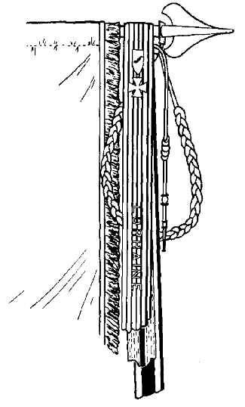
Stan Contrades - US Military Streamers; they are a visual record of unit service and award with precedence for streamers as unit recognition going back to Roman times. It was asked whether there are streamers used at sea and there aren’t except for commissioning pennants which can be rather long depending on length of service, according to Peter Ansoff; Tom Fahres asked if silver bands instead of embroidered streamers are still used as they were briefly during WWI (not so much now). The Union during the Civil War had their name and unit on the unit color while the Confederates had theirs in the field of their flag in the event it was captured. Al asked what the difference was between a cravat and a streamer? A cravat is a single piece tied to look like a bow or knot while a streamer is attached to the finial at the top. Why was the US military known as an Expeditionary Force in WWI Russia and it was thought that was because it was the first international force at the time.

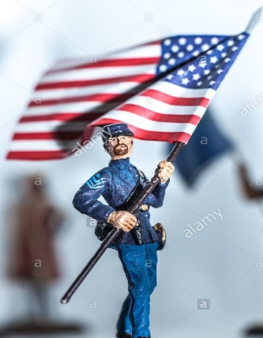
Arthur Etchells - My Interest in Historical Flags; World, European, and military history has always been a hobby and flags and heraldry in uniform that is considered ‘nonverbal identification’ His collections include miniatures and models carrying flags and a full library of books at home. Tom Carrier asked how far back do papal flags go and was answered that they go back to at least to the Middle Ages (although hard to tell if it was for the Pope or for the Papal States). There was a question on one of the Russian civil war flags as initially identified as a flag of Kerensky with the world Soviet on it; Arthur agreed it was more likely Soviet than Kerensky era.

John Andrews - US Space Force Flag; The unit flag for the new Space Force, authorized by President Trump, came into being on December 20, 2019 as a very dark blue (almost black) field for space, a delta wing as the prominent device with an elliptical symbol surrounding it, a white Polaris and two sets of star fields (oddly similar, it was suggested, to the seal of the United Confederation of Planets in the Star Trek TV series). Al asked why, if the Space Force is so recent, that the flag is placed in a priority over the Coast Guard flag when the Coast Guard was founded much earlier. It was asked whether the Public Health Service is military, and Chris Bedwell said it is a uniformed service just like NOAA (National Oceanographic and Atmospheric Agency). Stan suggested that the Coast Guard is not a military defense service whereas the Space Force would be if it were armed. Some discussion about the use of Roman numerals instead of a western style date of founding. Stan Max felt the flag design is good, but would have preferred it with fewer stars and without the name of the agency or its founding (even in Roman numerals) as it doesn’t conform to the principles of ‘Good Flag, Bad Flag.’

Greg Nedved - The Tricolor Flag of the Republic of Molossia; This micronation in Nevada was created by Kevin Baugh in 1998. Its flag has three equal horizontal stripes of light blue at the top (for the sky), white in the center (for the snowy mountain tops) and light green at the bottom (desert).; it is identical to the national flag of Sierra Leone. Some questions revolved around its seriousness or how official it is with consensus agreeing there isn’t much of either; it’s just fun.

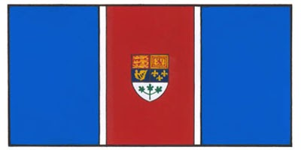
Chris Maddish - The Disputed Machias Seal Island Flag; Off the coast of Nova Scotia, Canada, is a 20 acre island with only a lighthouse and a few outbuildings, yet it has been disputed by the US and Canada since the Revolution. The flag Chris proposes would be like the 1931 proposed flag design replacing the shield with a red maple leaf and a yellow star on the fields of blue.

Business Matters

Peter Ansoff, President of NAVA, announced that NAVA 55 will again be a virtual meeting--not in St. Augustine, FL as originally planned when NAVA 54 became virtual. Instead, NAVA 56 will be in St. Augustine assuming conditions change. Check with the NAVA website for registration details.

Speaking of the NAVA website, a new service provider is working to ease the navigation issues; a restart is expected to be announced soon.

Peter was concerned about some public comments from the Flag Institute of the UK from NAVA Past President Scot Guenter who suggested that, among other things, flag design should not be part of the future of vexillology and asks all members to weigh in with comments.

Jack Lowe reported that the CBFA treasury balance is $253, but with no expenditures other than the cost of Zoom for virtual meetings. Once in-person meetings can be safely conducted, the auctions (where most revenue is received) will provide additional income.

Joe Radel, son of CBFA member Jon Radel, has helped update the CBFA website with more information on past meetings and history. Thanks, Joe. Visit the website at cbfa.vexillology.info and consider volunteering as its editor.

CBFA often gets emails from flag manufacturers, suppliers, dealers, and others. For the time being, Jack will continue to send these around, but asks members to let him know if they would like to opt out of these mailings.

Additional help is needed to broaden CBFA leadership and Jack asks for other members to consider hosting programs for future meetings, volunteer for publications and other ways to keep CBFA vibrant in the coming years.
Jack initiated a discussion on the future of CBFA as a regional organization or whether the group should become just another local ‘chapter’ of NAVA. Anthony Iasso enjoys getting together with the local flag community and Betty Brown just thinks more ‘in person’ meetings work better and likes the regional concept. Al Cavalieri likes the regional concept but believes that both NAVA and CBFA have value. Aracelli Fullem thinks that virtual meetings are here to stay even after in person meetings can be safely held again and enjoys the virtual meetings. David Wagner agrees that the ‘hybrid’ of virtual and in person meetings should be retained as much as possible. Stan Contrades likes that CBFA is independent and agrees that both virtual and in person meetings have a place. Mel Mason suggests that CBFA broadcast the connection of both the virtual and in person meetings in real time. Peter Ansoff, as president of NAVA, was asked by Tom Carrier whether he had any comments about chapters and said that he has no reason to object to regional chapters but also thought that regional meetings could be part of NAVA’s special interest sections, too. Tom Fahres, a new CBFA member, asks if it is necessary to also be a NAVA member and was assured that while it is not necessary, it is highly recommended. Tom Carrier, as recording secretary, finally counted no votes for CBFA to become part of NAVA rather than remaining an independent chapter.

Jack said that the mailing list has 67 people who have attended at least one meeting and a list of 140 others who have contacted him or have been identified by him as being in our area. Our two virtual meetings have had higher participation with 35 attending this meeting. For future virtual meetings, someone will assist by monitoring the chat and do other technical things.

New Business
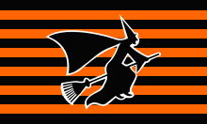
Peter Ansoff has repeatedly been asked about how to get copies of past NAVA meeting flags with the flag of NAVA 13, orange and black with a witch silhouette (Salem, MA 1979), as the overall favorite (although one youngster thought it represented the city of Wichita). Peter suggested a library of the meeting flag artwork be available for download for others to make copies on their own.

After a short break the meeting resumed with VexiBits

VexiBits

Ted Dahlberg - Flag of Corsica; first adopted by General of the Nation Pasquale Paoli for the small island between France and Italy in 1755. It shows a silhouette of a Moor facing the hoist on a white field with a white bandana around the forehead. Originally it was a blind fold.
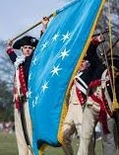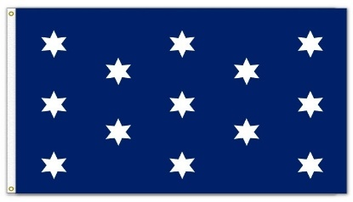
Al Cavalari - Commander-in-Chief Old Guard Flag is a light blue field (sometimes called George Washington blue or United Nations blue) with a circle of 13 six-pointed stars in a circle. It is a modified version of the George Washington personal flag as commander- in-chief of
continental forces during the Revolutionary War.

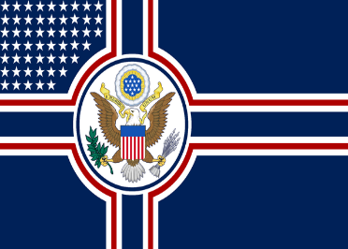
Connor Wright - redesigns flags into different versions based on history or how history could reinterpret the flag such as this USA flag redesigned in the style of the Third Reich. He showed his skill to the members by redesigning the Maryland state flag under different forms of governments using Adobe software.

Presentations

Anthony Iasso - Mystery of the 12-Star Flag: A most unusual flag in his personal collection of early American flags shows a 12-star flag rather than the expected 13 stars and was wondering why that was. The flag shows the expected stars of single applique linen and the stripes of colonial wool bunting, the hand sewn stripes and whipstitched grommets of the era. But why 12 stars? The possible answer is that Rhode Island did not send a delegate to the Constitutional Convention nor sign the final document in 1788. Flag makers (mostly individuals) assumed that there were only twelve states instead of the thirteen and so made a flag of only twelve stars. Tom Carrier asked if there were no original 13-star flags from the 18th century and Anthony suggested that there were no 13-star flags of the colonial era extant, but quite a few from the Federal period around the debate and signing of the Constitution.

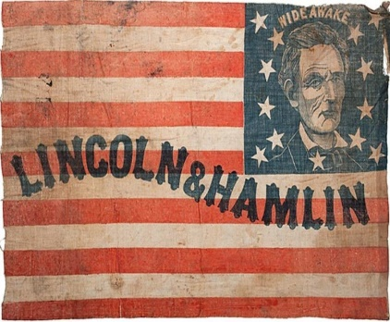
Nick Artimovich - The President and the American Flag in the 1800’s; The use of the American flag has been associated with presidents since the early Republic. Hoisting flags at the current Inauguration, for example, on the US Capitol only continues the tradition through presidential campaigns beginning with William Henry Harrison in 1840 such as the Lincoln & Hamlin example. The use of the flag with presidential campaigns and with presidents in product advertisement without approval of the president led to the first Flag Code in the 1920s that provided the proper etiquette for the use of the national flag.

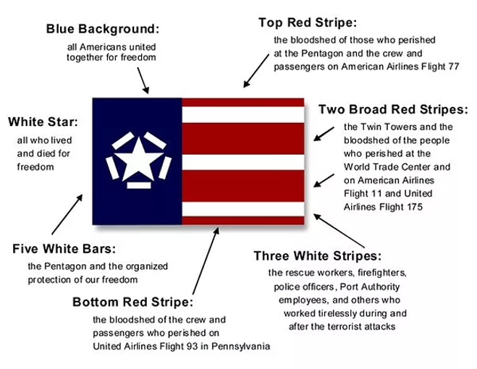
John Riley - The Freedom Flag Foundation; sponsors the Freedom Flag created by Richard Mileto to honor the nearly 3,000 who lost their lives during the September 11, 2001 attacks. Schools, groups, and government offices were particularly encouraged to remember the deaths by adopting and flying the red/white/blue Freedom Flag. All states and territories have adopted the use of the flag, except South Dakota which is expected rather soon. Visit the official website for more details as to its meaning and its progress.

VexiBits (continued)

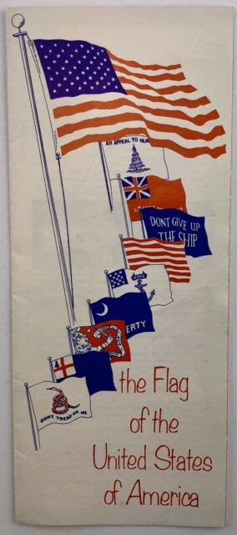
Betty Brown was fascinated by a pamphlet put out by Pacombo’s Pharmacy in 1973 that she bought at an estate sale. It shows the story of the US flag and includes references to both Betsy Ross and Francis Hopkinson. Especially during the US Bicentennial, many groups, businesses, and local governments produced pamphlets about the history and the guidelines regarding flag etiquette and usage of the flag of the United States as a marketing device and are routinely available on eBay and other sites for a few dollars.
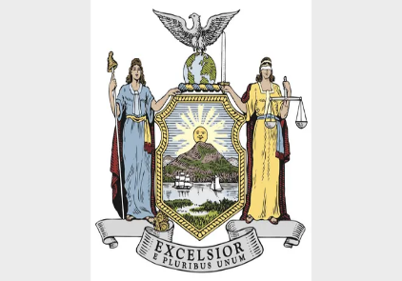
Al Cavalari - New York State Flag is to change its motto to include ‘E Pluribus Unum’, according to a proposal by New York Governor Andrew Cuomo that was approved in April 2020.

General Discussion

There was a general discussion as to whether the military and those in uniform are expected to render a salute to the President-elect and Vice President-elect of the United States before they are officially inaugurated. Tom Carrier mentioned watching C-SPAN when the President-elect and Vice President-elect were walking in the US Capitol on their way to the inaugural platform; the military did not salute either one, but some honors were rendered that didn’t include a salute.

The display of nearly 200,000 parade flags on the National Mall for the Biden-Harris Inauguration was discussed. Someone wondered how to get one of the flags as a souvenir. The immense flags handing vertically on the west front of the Capitol were made and supplied by Dixie Flag of San Antonio, hosts of the last ICV in 2019.

There was also a discussion as to whether Joe Biden was officially president when he took the oath of office ten minutes early or whether he was only official at twelve noon. It was unanimous that the Constitution specifies twelve noon as the official transfer of power and an early or late oath doesn’t change that.

It was pointed out that an earlier graphic of the Commander-in-Chief Guard flag was shown in an earlier 19th century representation of Liberty handing the circle of stars flag to George Washington Masonic Memorial building in Alexandria, VA. (site of NAVA 45/ICV 24)

The meeting ended at 3:20 PM.

Respectfully submitted.
Tom Carrier (recording secretary)

