**CHESAPEAKE BAY FLAG ASSOCIATION**

Minutes — October 3, 2021 — Zoom Online

10:12 am to 2:30 PM (EDT)

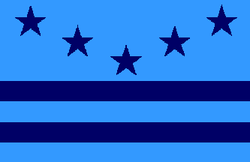

***Meeting to Order***

Members arrived online on the Zoom platform for a virtual meeting hosted by President **Jack Lowe** in Bethesda, Maryland with members joining from Virginia, Maryland, New Jersey, Pennsylvania, and New York.

President Jack Lowe brought the meeting to order at 10:12 am (EDT). Tom Carrier, Recording Secretary.

President Lowe began with introductions. There were no first-timers.

* Al Cavalari NY, owner, Flag Guys, NAVA member since 1989
* Art Etchells PA, military and historical flags, NAVA member since 1973
* Carlos Morales PA, subnational flags, research, NAVA member since 2015
* Chris Bedwell DC, subnational, city, obsolete flags, NAVA member since 2005
* Chris Maddish PA, history and flag patterns, NAVA member since 2008
* Daniel Broh-Kahn MD, UN flags, NAVA member since 90s
* David Maggi, NY, general flags
* Desmond O’Neill NJ, military flags
* Ed Jones, VA, flags in religion, politics, art, international
* Greg Nedved, MD, flags in folklore, flag trivia, and flags in general
* Gus Tracchia NY, Latin American flags, NAVA member since 1981
* Jack Lowe MD, President CBFA, Flag books, NAVA member since 1977
* John Andrews, NJ, NAVA member since 2018, Middle East and flags of Shakespeare
* John Baky PA, military, heraldry, researcher LaSalle University
* John Emond MD, American Rev/CW, NAVA member since 2011
* Jon Radel VA, cofounder CBFA, UN flags, Natl Geographic
* Mel Mason, MD, interest in general flags
* Nick Artimovich MD, cofounder CBFA, early American flags, collector, books, NAVA member since 1974, former NAVA president
* Peter Ansoff VA, President NAVA, Revolutionary War, general flags, origin of US flag, NAVA member since 1982
* Stan Max, MD, nicely designed flags, general flags interest
* Tom Carrier VA, cofounder CBFA, official flags, president, government, NAVA member since 1980

President Lowe proceeded with the Business Meeting.

* [CBFA website](https://cbfa.vexillology.info/) (cbfa.vexillology.info) is up and running with additional information available such as meeting meetings dating back to 2006 for review, a few presentations (there is a need for more), photos, and members in the news. The website was to be edited by Carlos Morales but he isn’t available now. Jack suggested the site be crowdsourced for those who can upload information when possible.
* Jack is also looking for information for the CBFA newsletter, Flagship. Send along content, please.
* Jack mentioned that during the pandemic Zoom meetings were attended rather well, but have since shown lower attendance due to people having more activities now. Still, attendance is consistently about 20-30 by Zoom.
* The Flag Institute in the UK is celebrating its 50th year ([flaginstitute.org](https://www.flaginstitute.org/wp/)) with their live streamed meeting on November 20th. CBFA members are encouraged to attend online.
* The next CBFA meeting will be in late January or early February, probably by Zoom again.
* The new NAVA website is up and is easier to use (it really is) thanks to Ted Kaye.
* Jack also asked for possible meeting sites and asked for members to check with certain flag-related exhibits in their area that future meetings can visit. Some guidance: when calling, consider yourself as planning officers of the CBFA. Ask:

1) Do they have flag material that might be of interest? If the initial person doesn't know, ask to contact a curator or collections supervisor about their holdings.

2) Would they be able to make a presentation to us as a group (5-15 people), and/or give us a tour, sometime in 2022 or 2023. If so, could it be a weekend day or does it have to be a weekday? If they respond positively

3) Would they do this gratis or expect a fee? (Make a big deal that we are flag experts and might even be able help them understand things they have)

4) Anything else you can think of.

Some suggestions:

* + Greg Nedved--Cold War Museum
  + Peter Ansoff--Mariners Museum
  + Mel Mason--Maryland History Center
  + Ed Jones--Fredericksburg area (? Mary Washington House, ?National Military Park ? any museums)
  + Tom Carrier--White House Historical Society, Capitol Historical Society
  + John Emond--Daughters of the American Revolution (DAR)
  + Jon Radel--Army Museum
  + Dale Grimes--US Navy Museum
  + Anyone with contacts at the US Naval Academy or the MD Archives?

 

**NAVA Update by President Peter Ansoff**

NAVA Website

The new [NAVA website](https://nava.org/) (nava.org) has new functions, are able to renew memberships, and ability to update personal information directly. “Pete Losier, Ted Kaye, Annie Platoff, all did a fantastic job,” says Peter. Check out the publications and help fill any hole. The next project is to complete a full index of all vexillological material ever published under the International Vexillological Index (IVI) project to be managed by Annie Platoff and John Andrews Send them any information.

Vexillum 15 and Raven are out. Vexillum 16 will be the last edited by Steve Knowlton with great thanks for his great work through the years. Peter Lichtgarn will take up as Vexillum editor with Vexillum 17.

The annual election notice will arrive soon with only the First Vice President and the Treasuer on the ballot.

NAVA Meetings Update:

- NAVA 56 will be an in-person meeting in St. Augustine, FL in 2022 with meeting dates to be announced.

* NAVA 57 will be held in Monterrey, Mexico, in 2023 the first time a meeting will be held south of the border. Meeting dates will be announced.
* NAVA 58 is being discussed for Philadelphia, PA in 2024.
* John Edmund wondered if NAVA meetings will be a hybrid of in-person and online meetings; this is being investigated. NAVA 56 in St. Augustine might have that capability at Flagler College.

Interest Area Meetings:

- Revolutionary War flags will be the topic on October 11th to explore the often-misunderstood origins of the many flags of the era.

- Art Etchells is considering a more formal course for vexillology in November based on the criteria from our recent past CBFA presentation by Stan Contrades, NAVA First VP.

NAVA Board Meetings are open to any member and just need to email Secretary Ted Kaye to get on the list at [sec@nava.org](mailto:sec@nava.org)

Presentations

[**NASA Flags for Heroes and Families**](https://www.nasa.gov/topics/nasalife/features/sept11_flags_on_orbit.html)

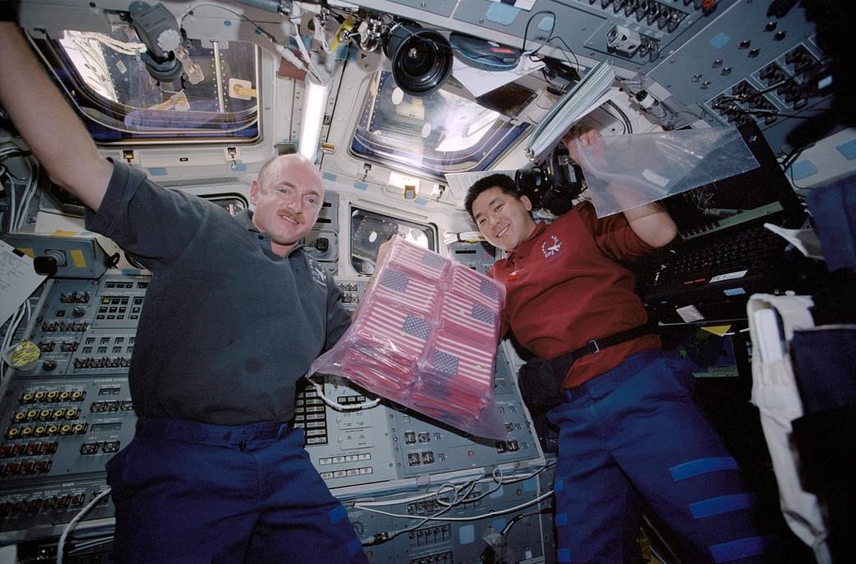

*Astronauts Mark E. Kelly (left), STS-108 pilot, and Daniel M. Tani, mission specialist, hold a bag of several American flags on the aft flight deck of the Space Shuttle Endeavour. The flags carried on the shuttle include 6,000 small U.S. flags, one U.S. flag that was recovered from the debris of the World Trade Center, a Marine Corps flag that was retrieved from the Pentagon, and an American flag from the State of Pennsylvania. Also onboard, is a large New York Fire Department flag, 23 replica New York Police Department shields, and 91 New York Police Department patches.*

Last September 11th was the 20th anniversary of the attack on the World Trade Center, the Pentagon and the loss of Flight 93 in Shanksville, PA where passengers fought the terrorists’ intent to use the plane to destroy the US Capitol in Washington, DC. **John Emond** tells the story of US flags and others that were recovered or flown over the three sites that were sent into space aboard the space shuttle by NASA in honor of the victims of 9/11. Al Cavalari asked how many flags were flown to space and Tom Carrier answered only a few hundred during the early NASA space launches, but at least 10,000 aboard the International Space Station at one time.

**Flags at Mauna Kea**

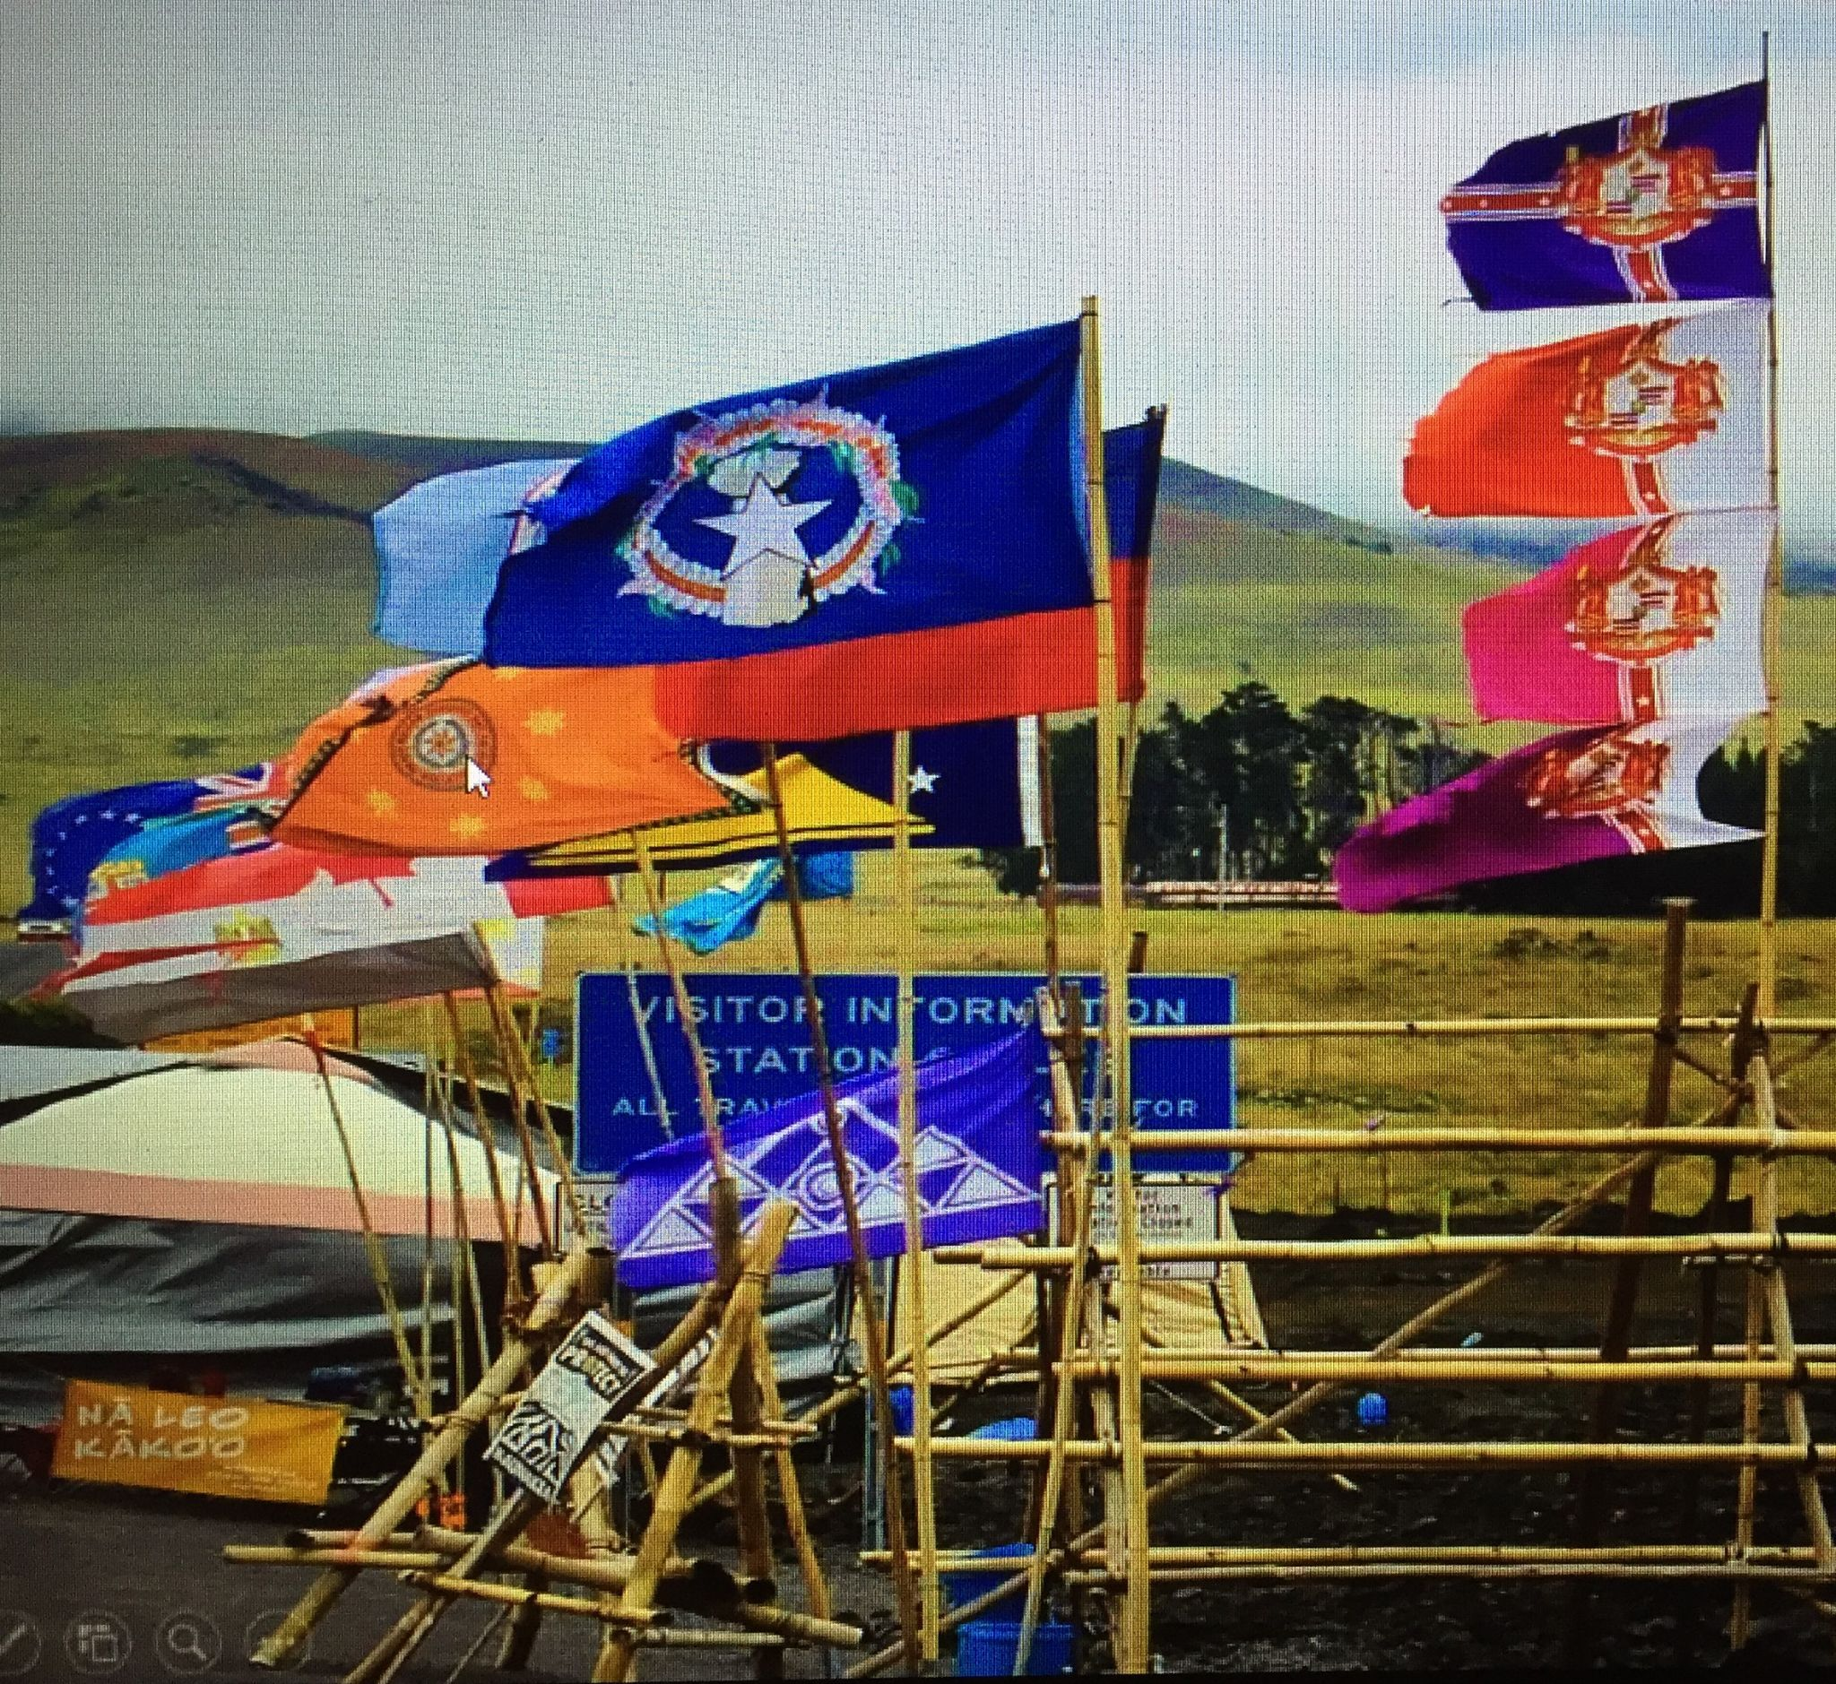

Demonstrations have been held at the Mauna Kea Observatory in Hawaii to protest the climate changes affecting Mother Earth, according to the indigenous population. **Gus Tracchia** recounts that several flags, including the flag of the State of Hawaii hung upside down in distress, feature the color of the natural plant colors for each region. Many flags were also represented such as the Cook Islands, Fiji and the Philippines.

**Presenting the Black Camp Loyalist Heritage Flag**

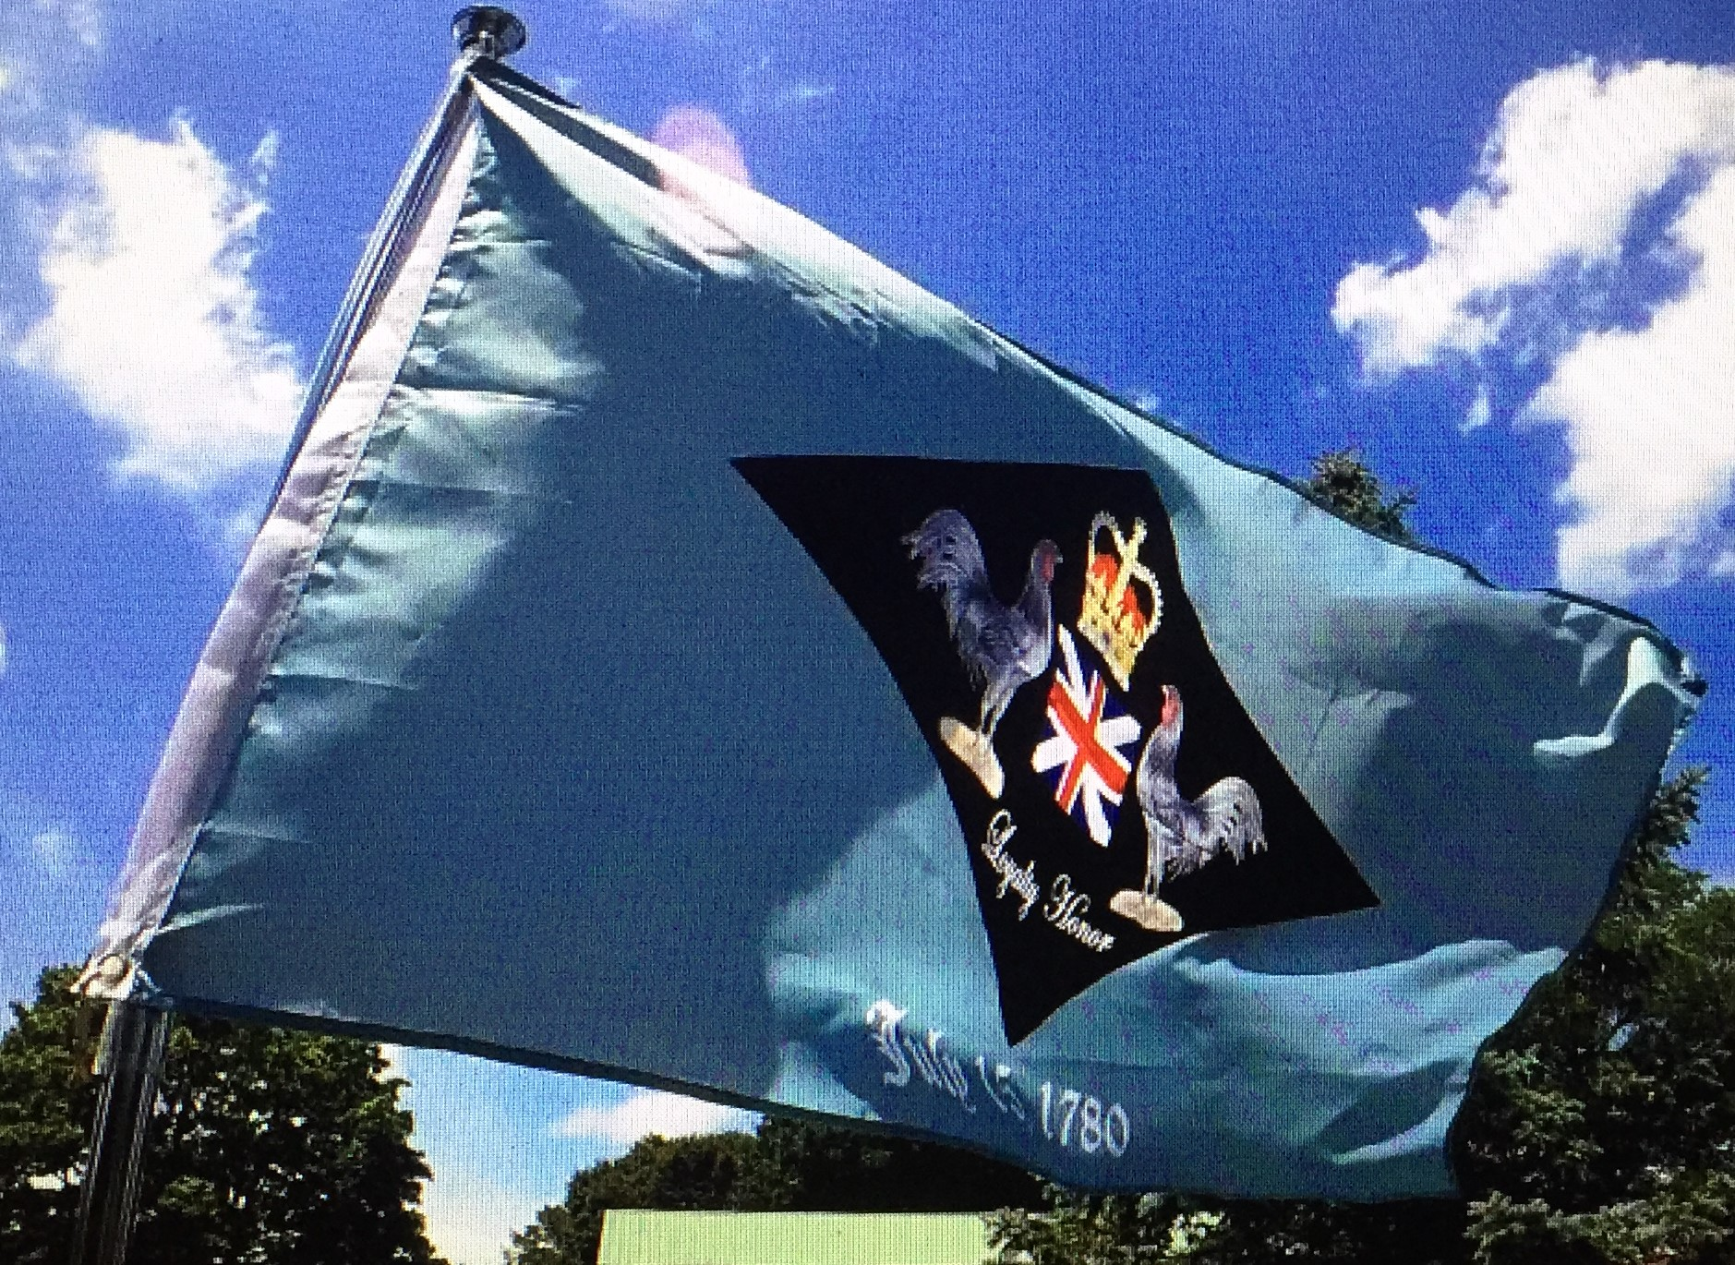

**Chris Maddish** unveiled a variant of flags based on historical events such as the one for the dividing line between opposing forces of US and Canada of 1763 at Ellendorf, Delaware. Also, Harriet Tubman was featured on the flag of the Commonwealth of Virginia and the 45th Parallel Flag that is the halfway point between the Equator and the North Pole.

Break from 1:05 to 1:15

**Six-Sided Simulations**

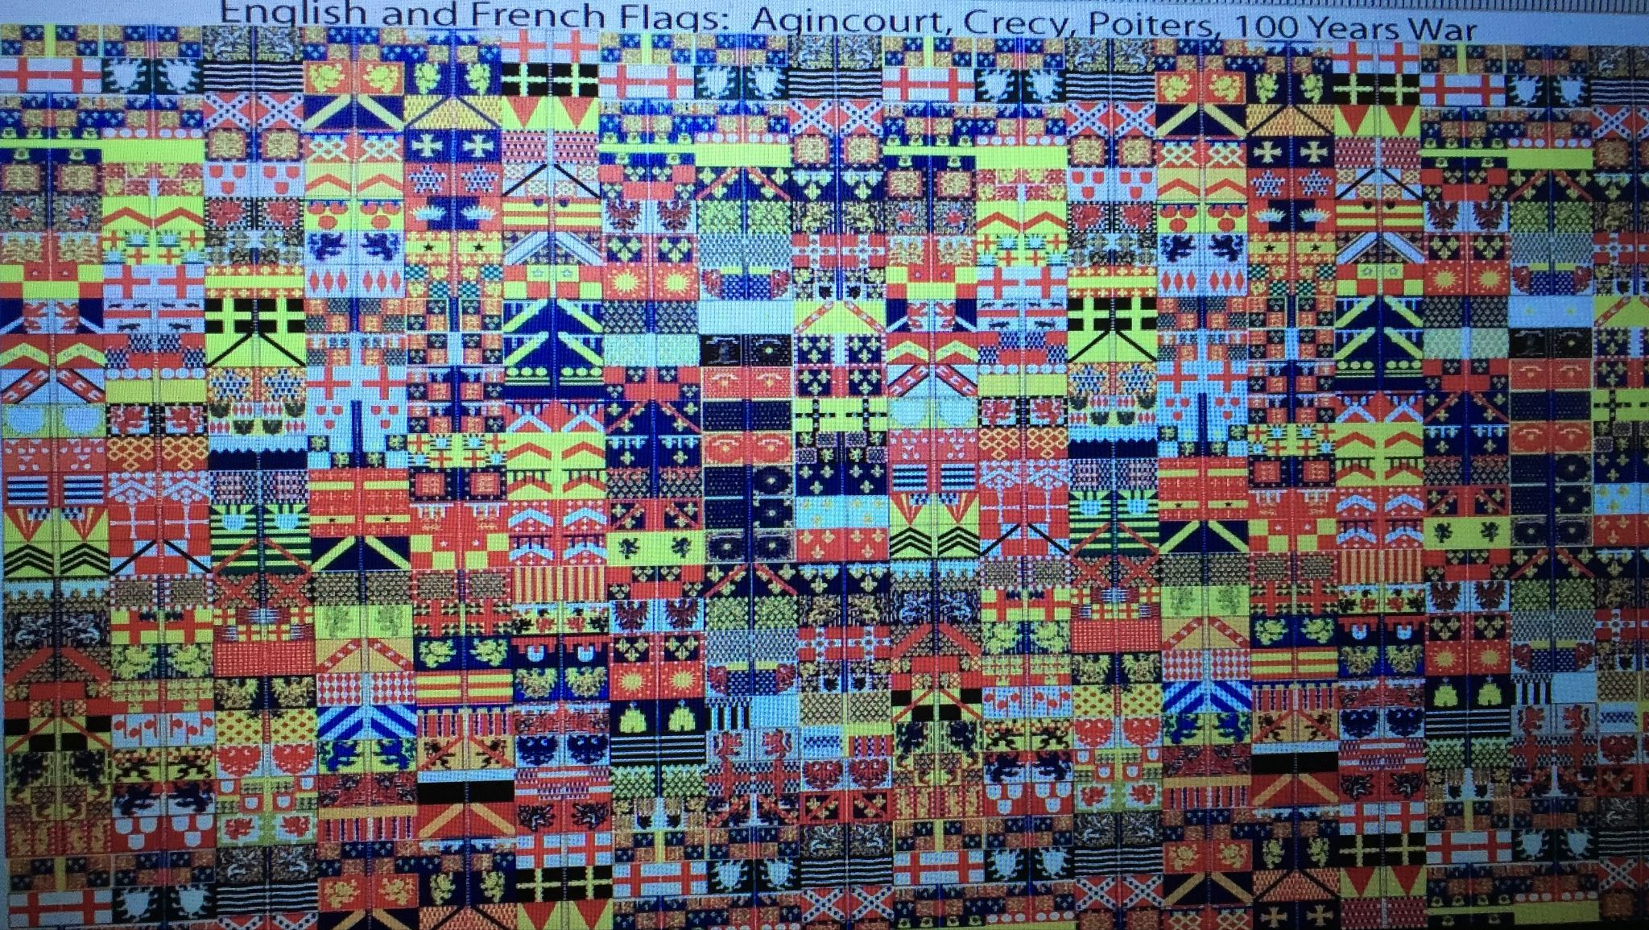 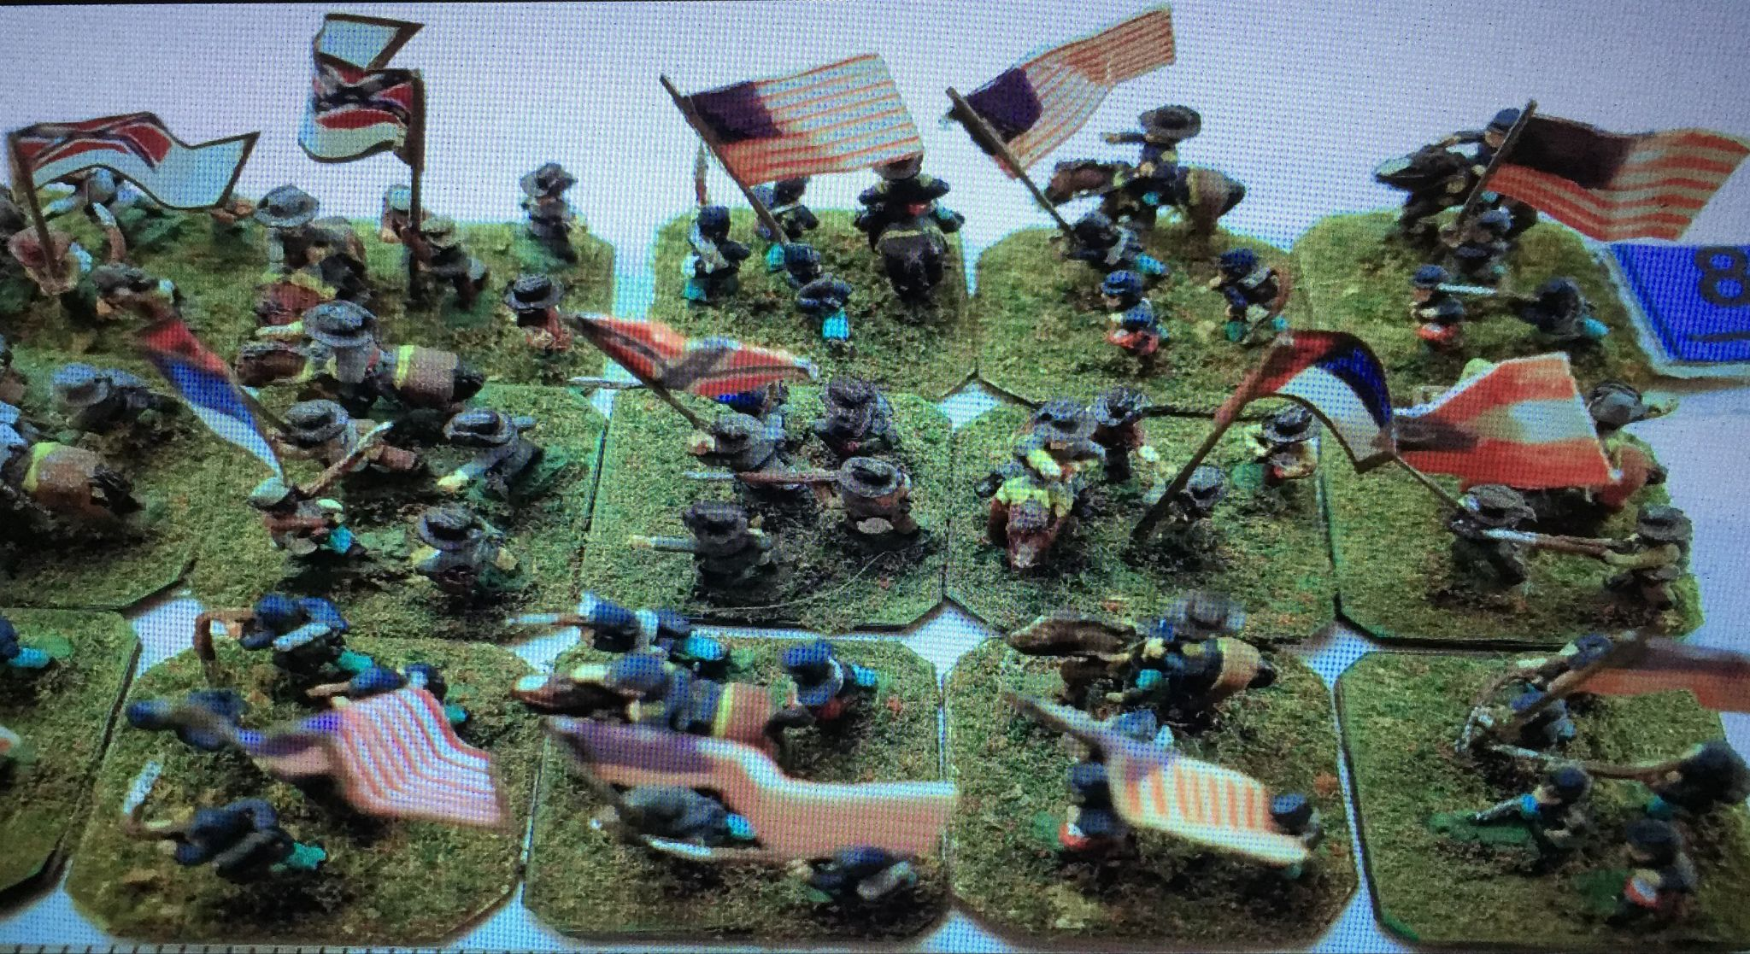

For a long time, hobbyists creating flags for miniatures used the cut out and tape method if they didn’t paint the flags on the miniatures themselves. **Daniel Bro-Kahn** instead created more accurate representations of historic battle flags in the same manner as postage stamps that peel and stick that he sells for $10 a sheet. The most popular stickers are for the Napoleonic Wars. Art asked if there is a sheet that identifies the flag and Daniel said that there isn’t for the moment. He is open to producing the sheets in poster form.

**Good Display; Bad Display**

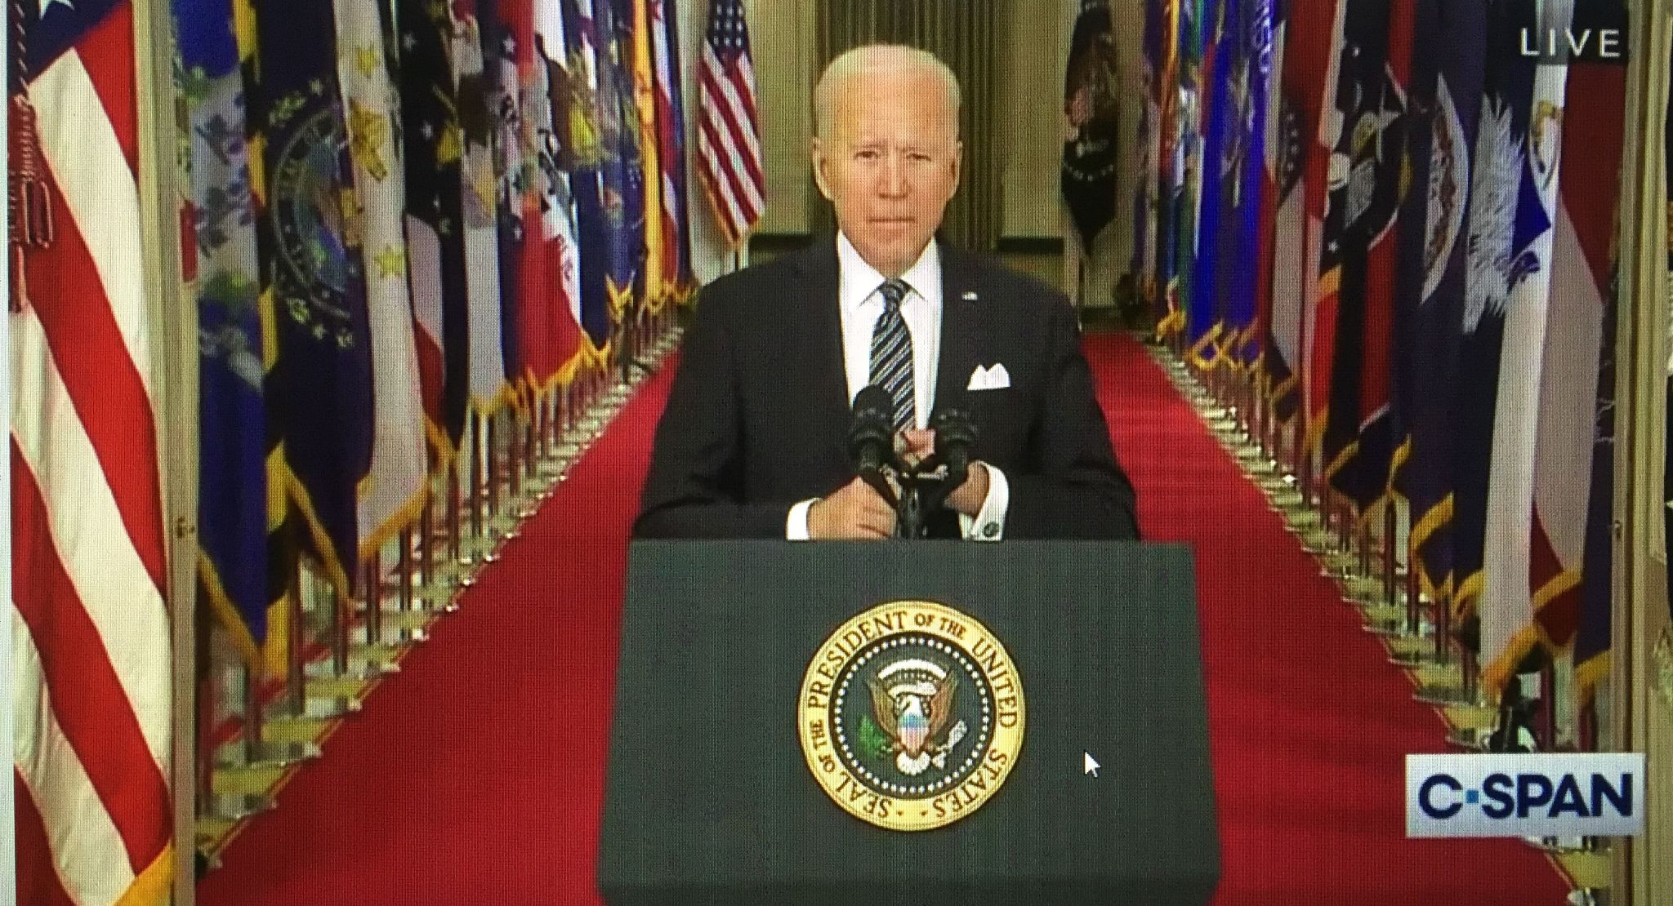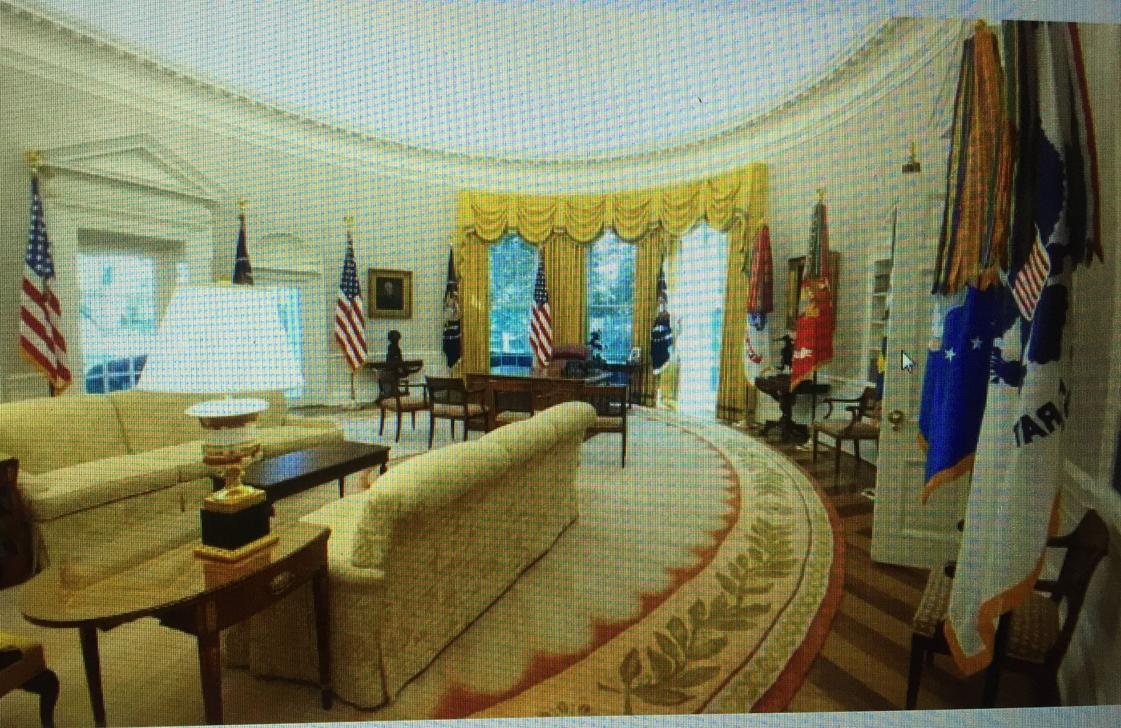

At the last CBFA meeting **Al Cavalari** showed images on the use of the US flag at official or photo op events over the past few years. This time, Al created a review of 15 images, and asked people to vote whether the display was a good display or a bad display of the US flag. The results were quite interesting—people felt that a number of US flags that were flown loose were both a good and a bad display depending on how they were arranged. The image of President Trump hugging a US flag seemed to be the only president, government official, or candidate at any level to have done that. This was not well received by the group. He was also the only president to have at least four sets of president and US flags and two full displays of all military flags in the Oval Office at one time; that was also not well received. The consensus was that too many flags diminish the power of the symbol--what **Tom Carrier** called “the potted plant” syndrome where the display becomes more decorative than symbolic. The discussion was spirited and lively and was interrupted to conserve time for the final presentation.

**Why are Taliban Flags White?**

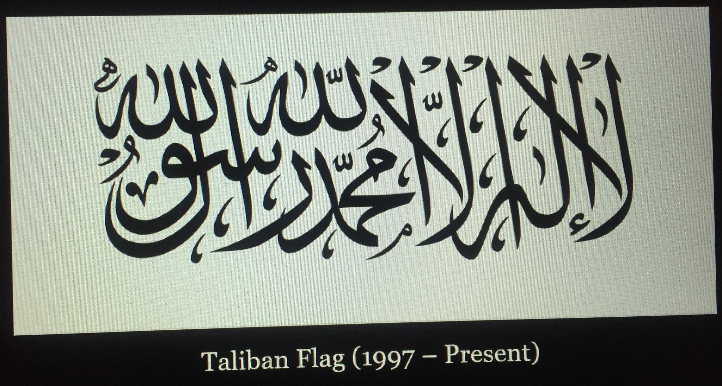 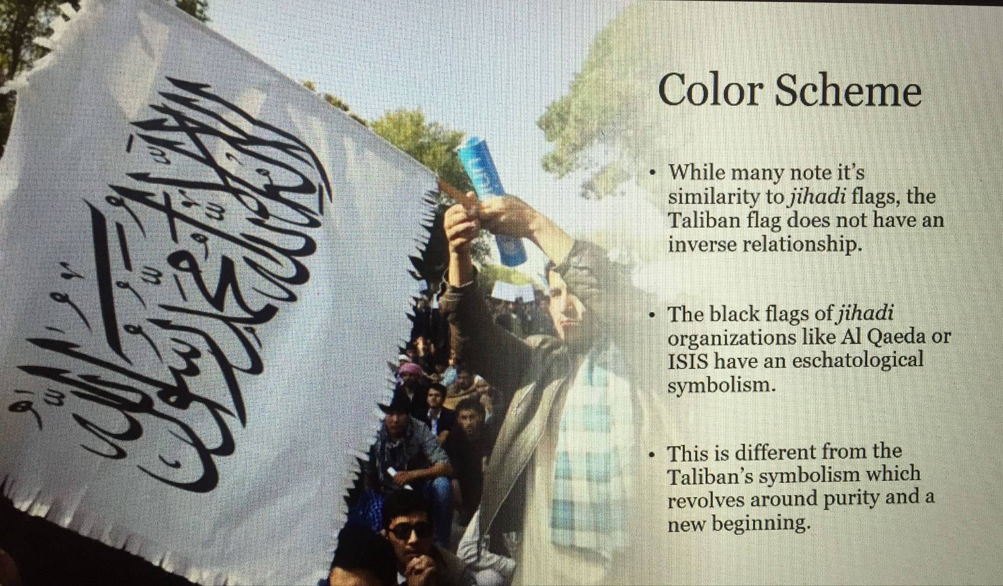

We are familiar with the flag of ISIS as a black field with a white Shahada. The Taliban, a more fundamental Islamic group, has resumed control of Afghanistan Their flag is the reverse, a field of white with a black Shahada. **John Andrews** explains the differences as the former is more of a political statement while the latter is more a symbol of purity. Stanley Max didn’t consider it a good design because of the stylized Arabic script, insisting that one of the rules of a good flag is that it not incorporate words. However, it was pointed out by Peter Ansoff that certain words are symbols themselves such as ‘Don’t Tread on Me’ from the US Revolutionary War.

**Good Display, Bad Display (cont’d)**

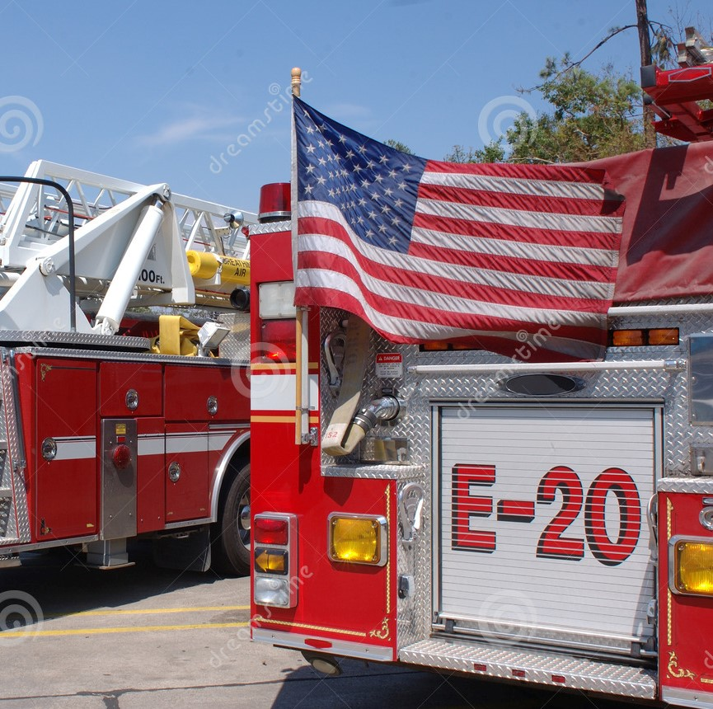 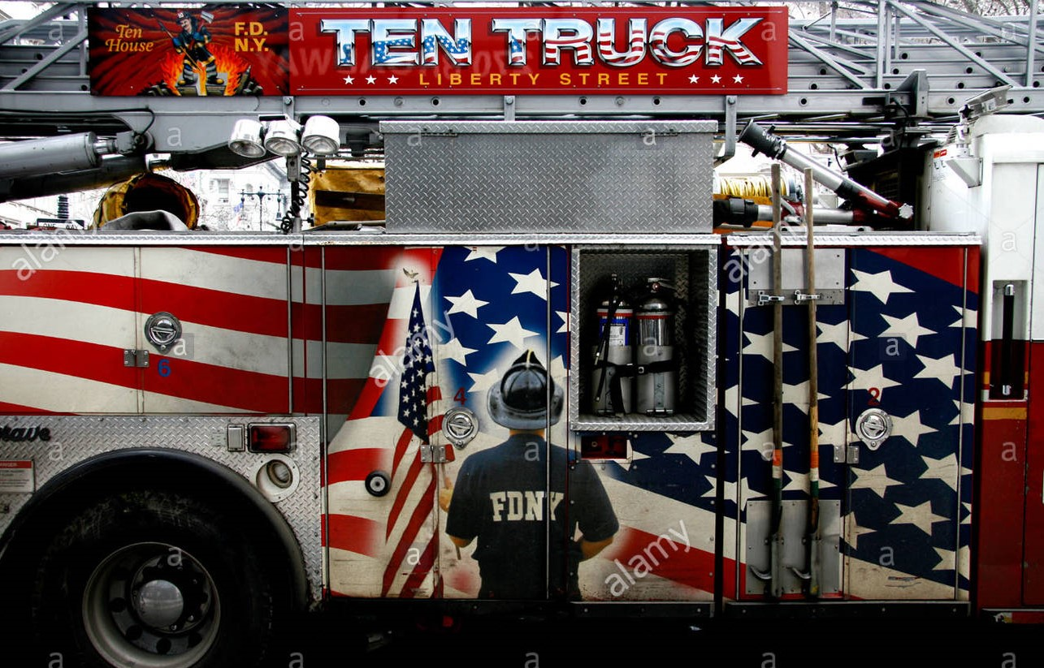 

Discussion resumed about Al Cavalari’s **Good Display, Bad Display.** More of the images were shown with comments from several members. For example, flags flown from the back of fire trucks were considered an impediment during fire operations and called disrespectful by one local jurisdiction and a ceremony was held to “hand off” the flag to a different fire company for “safe keeping.” Participants split on whether it was a good display. An oversized US flag used on a playing field was considered a good display even if the Flag Code doesn’t allow it (when laid flat, hats that were thrown in the air might land on it was the explanation). Tom Carrier thought the entire discussion was worthy of a NAVA meeting.

Meeting ended at 2:30 PM.