Chesapeake Bay Flag Association 9/11/22 (on Zoom)
19 in attendance—first timers in italics
John Andrews, Peter Ansoff, Nick Artimovich, Chris Bedwell, Daniel Broh-Kahn, Cameron Cayer, John Emond, Art Etchells, Zachary Gardiner, Griffin Goff, Isaac Harder, Jack Lowe, Christopher Maddish, Anthony Morales, Carlos Morales-Ramirez, Dejan Mraovic, Jon Radel, Tara Stark, Gus Tracchia
Meeting began at 10AM.
I INTRODUCTIONS: Participants each gave a brief introduction. Three new faces, one a college student.
II A MOMENT OF SILENCE to remember the tragedy of September 11, 2001 on the 21st anniversasry.
III PRESENTATIONS:
- Nick Artimovich showed many British and UK royal standards, coronation flags and other flags commemorating new sovereigns.
- John Emond spoke about Flags that Unite, Flags that Divide—The Flags of Northern Ireland. This is the second part of his talk. Last time he spoke about the Red Hand of Ulster flag. The talk was illustrated with photos John has taken over the past 50 years on trips to Belfast and Derry/Londonderry and shows the many changes that have occurred in daily life, but the persistence of the “flag divide” as a shorthand for the deeply divided country.
- Zachary Gardiner presented a short talk on the flag of the 4th Infantry Regiment that fought at the Battle of Tippecanoe in 1808. The actual flag was captured and is still in Great Britain. A loan to the local museum in Indiana (which has a replica) couldn’t be arranged because they didn’t have proper conditions for handling and displaying it.
- Gus Tracchia reported on his poll after the last meeting where he asked if people considered the flags of Brazil and Dominican Republic to be bicolors or tricolors. There was no consensus in our group. Gus said that Brazilians regard theirs as a bicolor, the blue just being an added emblem. The President of Brazil’s sash is just green and yellow; however, Brazil’s national football (soccer) team wears yellow shirts with green numbers and trim, but also blue shorts. Dominicans don’t see their flag as two colors with a white cross; they see a tricolor. Nick suggested that the terms bicolor and tricolor should be kept for striped flags and the flags under discussion should be called two-colored or three-colored.
- Art Etchells showed photos of the Wannamaker flag collection which was displayed this summer at the Philadelphia Center City Macy’s (in the historic Wannamaker Building). The collection is occasionally (and unexpectedly) shown at the store.
- Tara Stark showed the Keystone flag that she and others are proposing as an alternative to the current Pennsylvania state flag. (keystoneflag.org) . She discussed the problems of flag change and ways to get political buy in. Nick told a story of how a Pennsylvania state office building was flying the New York state flag. You can see the photo on the CBFA website.
- John Andrews gave a talk on flags and copyright. He showed the nuances of the law, based on an actual case of the Cooperstown Bat Company and the American Bat Flag.
IV BUSINESS MEETING:
1 Reports—Jack Lowe
- The minutes of the meeting of March 2022 are on the website (CBFA.vexillology.info)
- The treasury has $81, not having any auction income since 2018 and having the expenses of the Zoom account and NAVA dues.
- “Membership” report shows 290 people on the mailing list. 50 individuals have attended at least one meeting since Zoom meetings began in May 2020. The 2017-2019 average attendance had been 12: max 22 (December 2018). The 2020-2022 average attendance was 23: max 35 (January 2021). There is a “core group” of about 15 (attended more than ½ of meetings in the past five years).
2 Old Business
- Newsletter (on website or emailed): this has been in abeyance for a while, but Carlos is willing to start rethinking what we can and should do. Anyone interested in working with Carlos on this project can get in touch with him through cbfamail@gmail.com.
- Instagram: Zachary oversees our new Instagram account. He reported that we already have about 70 followers. He discussed the difference between posts and stories and informed us how other vexillological organizations use their Instagram. Ideally, we would post on a regular basis. Anthony and Tara will help Zachary out.
3 New Business
- The Libby Collection: Our dear member the Reverend Richardson (Dick) Libby jr. died in April 2020 during the Covid-19 pandemic. His widow and sons are clearing the house of his collections. Kathryn, Rich, and Roger Libby have generously donated his collection of flags to CBFA to be distributed to flag lovers. To this end, we will have a special meeting this winter (date TBD) in Baltimore to distribute the several hundred full size flags and hundred or so table flags. Some or all will be auctioned to replenish our treasury.
- A poll was conducted to see whether Saturday or Sunday was the preference for the winter meeting. It was a tie. When the date is finalized, the membership will be informed.
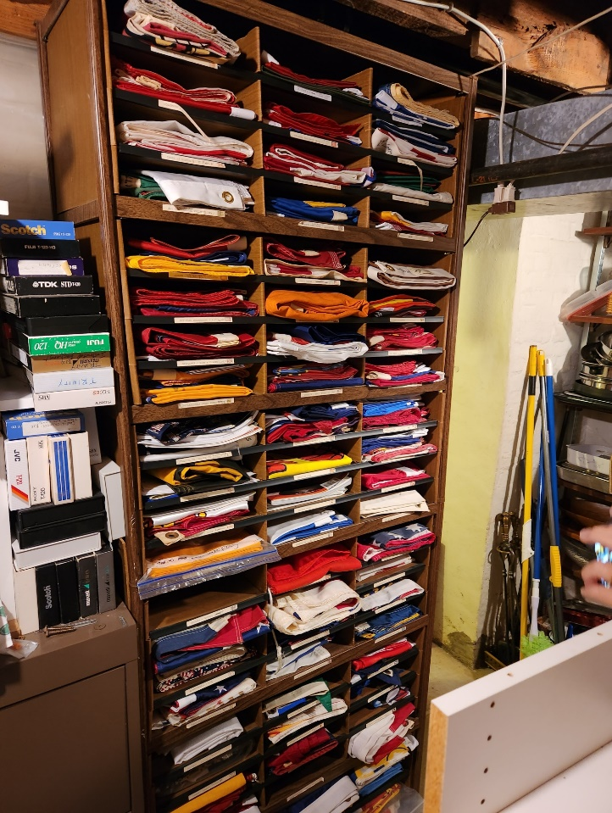

- The Future of CBFA: Jack brought up the following: Regional groups were started in the 80s because that was the only way to learn about and talk about flags other than the annual NAVA meeting. Is there still a need for a regional group in this era of internet resources and cyber meetings, especially with the expanded offerings of NAVA? Will resumption of in-person meetings change things back to before? If we go back to those meetings at homes and other venues, what can we do about the people in the farther reaches of our catchment area? Should we advertise our meetings beyond the region?
There was a good discussion of the need to continue CBFA as a regional flag group. Barring further worsening of the pandemic, we will plan all our meetings in person with a Zoom or streaming component for those who are unable to attend.
Jack also announced that he is planning to step down in January 2024 when he turns 80. Over the next year, we will decide on having either a slate of officers or a management committee to plan and coordinate meetings and emails.
V NAVA UPDATE: Peter Ansoff
- NAVA 57 will be in Philadelphia the weekend of October 6-9, 2023. Art is one of the organizers and more help is needed from Pennsylvanians. Please contact Peter at pres@nava.org
- Interest area meetings are going quite well. It has turned out to be an interesting program.
- Membership is a little under 800, almost double the membership in 2017
- Election of Officers is coming up. It is online and Peter explained how to make nominations “from the floor.”
VI ADJOURNMENT: 1:15 PM

